 | 26.2 Editors - Properties Editor - Render Properties Tab
Table of content
Detailed Table of content 1
Render Tab 4
Sampling panel 4
Ambient Occlusion panel 4
Bloom panel 5
Depth of Field panel 5
Subsurface Scattering panel 6
Screen Space reflections panel 6
Motion Blur panel 7
Volumetric panel 8
Curves panel 9
Shadows panel 9
Indirect Lighting panel 10
Film panel 11
Eevee (Legacy) + Workbench - Simplify panel 12
Simplify panel 13

Detailed Table of content

Detailed table of content
Detailed Table of content 1
Render Tab 4
Sampling panel 4
Viewport Samples 4
Render Samples 4
Viewport Denoising 4
Ambient Occlusion panel 4
Enable 4
Distance 4
Factor 4
Trace Precision 4
Bent Normals 4
Bounces Approximation 5
Bloom panel 5
Enable 5
Threshold 5
Knee 5
Radius 5
Color 5
Intensity 5
Clamp 5
Depth of Field panel 5
Max Size 5
Sprite Threshold 5
Neighbor Rejection 6
Denoise Amount 6
High Quality Slight Defocus 6
Jitter Camera 6
Overblur 6
Subsurface Scattering panel 6
Enable 6
Samples 6
Jitter Threshold 6
Separate Albedo 6
Screen Space reflections panel 6
Enable 7
Refraction 7
Half Res Trace 7
Trace Precision 7
Max Roughness 7
Thickness 7
Edge Fading 7
Clamp 7
Motion Blur panel 7
Enable 7
Position 7
Shutter 7
Background Separation 8
Max Blur 8
Steps 8
Volumetric panel 8
Start 8
End 8
Tile Size 8
Samples 8
Distribution 8
Viewport Volumetric Blending 8
Volumetric Lighting 9
Enable 9
Light Clamping 9
Volumetric Shadows 9
Enable 9
Samples 9
Curves panel 9
Shape 9
Additional Subdiv 9
Shadows panel 9
Method 9
Cube Size 9
Cascade Size 10
High Bit depth 10
Soft Shadows 10
Indirect Lighting panel 10
Bake Indirect Lighting 10
Bake Cubemap Only 10
Delete Lighting Cache 10
Auto Bake 10
Diffuse Bounces 10
Cubemap Size 10
Diffuse Occlusion 10
Irradiance Smoothing 11
Clamp Glossy 11
Filter Quality 11
Display 11
Cubemap Size 11
Irradiance Size 11
Film panel 11
Filter Size 11
Animate Property 11
Overscan 11
Overscan Size 11
Eevee (Legacy) + Workbench - Simplify panel 12
Enable 12
Viewport 12
Max Subdivisions 12
Child Particles 12
Volume Resolution 12
Animate Property 12
Render 12
Max Subdivisions 12
Child Particles 12
Animate Property 12
Grease Pencil 13
Playback Only 13
Fill 13
Modifiers 13
Shader Effects 13
Layers Tinting 13
Antialiasing 13
Simplify panel 13
Enable 13
Viewport 13
Max Subdivisions 13
Max Child Particles 13
Volume Resolution 14
Shadow Resolution 14
Render 14
Max Subdivisions 14
Max Child Particles 14
Shadow Resolution 14
Grease Pencil 14
Playback Only 14
Fill 14
Modifiers 14
Shader Effects 14
Layers Tinting 14
Antialiasing 14

Render Tab
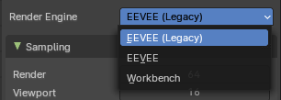
There are four different render engines available. Workbench, EEVEE, EVEE (Legacy), and Cycles. This chapter has a focus on the EEVEE (Legacy) render engine.

Sampling panel
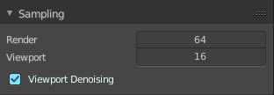

Viewport Samples
The number of samples when rendering in the viewport.

Render Samples
The number of samples when rendering to file.

Viewport Denoising
Denoise Image. The temporal re-projection can cause some ghosting.

Ambient Occlusion panel
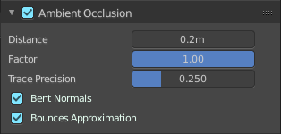
Ambient occlusion is a self shadowing effect.

Enable
In the header you will find a checkbox to enable the Ambient Occlusion.

Distance
The distance of the object to contribute to the ambient occlusion.

Factor
The blend factor

Trace Precision
Precision of the horizon search

Bent Normals
Compute the main non occluded direction to sample the environment

Bounces Approximation
An approximation to simulate light bounces gives less occlusion on brighter objects.

Bloom panel

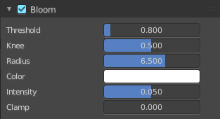
Enable
In the header you will find a checkbox to enable the Bloom.

Threshold
Filters out pixel that are below this level of brightness.

Knee
Makes transition between under / over threshold gradual.

Radius
Bloom spread distance.

Color
The color of the bloom effect.

Intensity
Blend Factor.

Clamp
Maximum intensity a bloom pixel can have.

Depth of Field panel
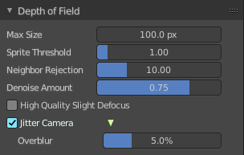

Max Size
The maximum size of the bokeh shape for Depth of Field. Lower is faster.

Sprite Threshold
Brightness threshold for using sprite base depth of field.

Neighbor Rejection
The maximum brightness to consider when rejecting bokeh sprites based on neighborhood. Lower is faster.

Denoise Amount
Amount of flicker remove applied to bokeh highlights.

High Quality Slight Defocus
Sample all pixels in almost in-focus regions to eliminate noise.

Jitter Camera
Jitter the camera to create accurate blurring by using render samples.

Overblur
Apply blur to each jittered sample to reduce undersampling artifacts.

Subsurface Scattering panel

Subsurface scattering is a mechanism of light transport through the object. It penetrates the surface of a translucent object, is scattered by interacting with the material, and exits the surface at a different point.

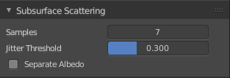
Enable
In the header you will find a checkbox to enable the Subsurface Scattering.

Samples
Number of samples to compute the scattering effect.

Jitter Threshold
Rotate samples that are below this value.

Separate Albedo
Avoid albedo being blurred by the subsurface scattering. This feature uses more memory.

Screen Space reflections panel

Contains settings around the Screen Space reflections.
Screen Space Reflections is a common technique in games. It reuses the information that is already on screen for reflections. It doesn't reflect geometry outside of the camera though.

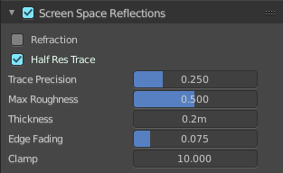
Enable
In the header you will find a checkbox to enable the Subsurface Scattering.

Refraction
Enable Screen Space refraction.

Half Res Trace
Ray trace at a lower resolution.

Trace Precision
The precision of the screen space ray-tracing.

Max Roughness
Do not ray-trace reflections that are above this value.

Thickness
Pixel thickness used to detect intersections.

Edge Fading
Screen percentage used to fade the Screen Space Reflection.

Clamp
Clamp Pixel intensity to remove noise.

Motion Blur panel

Contains settings for motion blur.

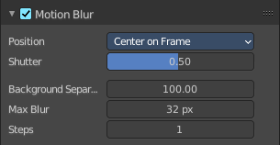
Enable
In the header you will find a checkbox to enable the Subsurface Scattering.

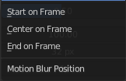
Position
Offset for the shutters time interval. This allows to change the motion blur trails.

Shutter
Time taken in frames between shutter open and close.

Background Separation
Separate background elements from foreground elements. Lower values will reduce background bleeding onto foreground elements

Max Blur
The maximum blur distance a pixel can spread over.

Steps
The accuracy of motion blur. Higher values results in higher accuracy and higher render times.

Volumetric panel

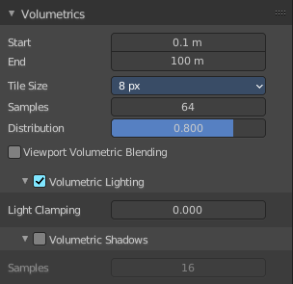
Contains volumetrics settings.

Start
The start distance for volumetrics.

End
The end distance for volumetrics.

Tile Size
The quality of the volumetrics effect. The lower the size the higher the quality and ram usage.

Samples
Number of samples to compote for the volumetrics effect.

Distribution
Distribute more samples closer to the camera.

Viewport Volumetric Blending
Enable volumetrics blending with previous frame in viewport. Attention, this setting is just for the viewport. The final rendering is not affected.

Volumetric Lighting

Enable
In the header you will find a checkbox to enable Volumetric Lighting.

Light Clamping
The maximum light contribution.

Volumetric Shadows

Enable
In the header you will find a checkbox to enable Volumetric Shadows.

Samples
Number of samples to compute volumetric shadowing.

Curves panel

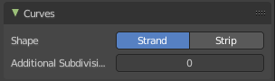
Shape
Choose if the hair is displayed as strand or as strip.

Additional Subdiv
Additional subdivision along the hair.

Shadows panel
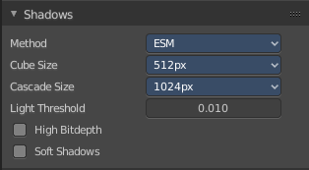
Contains settings regarding shadows.

Method
Choose between ESM and VSM method for the shadow. ESM stands for exponential shadow mapping. VSM stands for Variance shadow mapping.

Cube Size
The cube shadows resolution.

Cascade Size
Directional shadows resolution.

High Bit depth
Use 32 bit shadows. Low bit depth uses 8 bit.

Soft Shadows
Create soft shadows.

Indirect Lighting panel
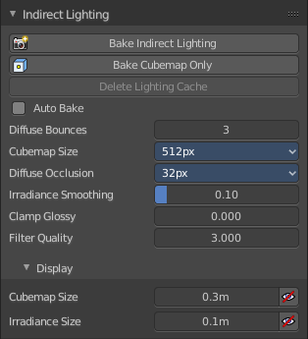
Indirect lighting can be baked to speed up the rendering process.
Eevee uses irradiance probes to calculate indirect lighting.

Bake Indirect Lighting
Bake both, the irradiance grids and reflection cube maps.

Bake Cubemap Only
Bakes only the reflection cube maps.

Delete Lighting Cache
Delete baked informations from cache.

Auto Bake
Auto bake indirect lighting when editing probes.

Diffuse Bounces
Number of times the light is reinjected inside light grids. 0 will disable indirect diffuse light.

Cubemap Size
The size of the cube maps.

Diffuse Occlusion
The size of the shadow map applied to each irradiance sample.

Irradiance Smoothing
Smooth the irradiance lightning. But this might introduce light bleeding.

Clamp Glossy
Clamp Pixel intensity to reduce noise inside glossy reflections from reflection cube maps. A value of 0 disables the clamping.

Filter Quality
Take more samples during cubemap filtering to remove artifacts.

Display

Cubemap Size
Size of cubemap spheres to debug captured light.

Irradiance Size
Size of the irradiance sample spheres to debug captured light.

Film panel
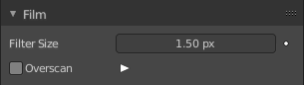

Filter Size
The width over which the reconstruction filter combines samples.

Animate Property
This property can be animated. Activating this button sets a keyframe.

Overscan
Internally render past the image borders to avoid screen space effects disappearing.

Overscan Size
How much bigger the image should be internally rendered.

Eevee (Legacy) + Workbench - Simplify panel
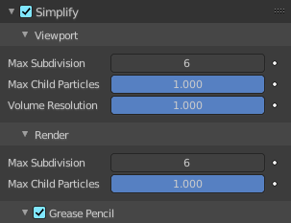
Sometimes you want to simplify the rendering without to loose the already tweaked settings and adjustments. For test renderings for example. Simplify allows you to simplify the rendering.

Enable
In the header is a checkbox to enable Simplify.

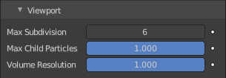
Viewport
This section affects the rendering with Eevee in the Viewport.

Max Subdivisions
Limit the number of maximum subdivisions.

Child Particles
Limit the number of child particles.

Volume Resolution
Simplify volumes by setting the resolution percentage of volume objects in viewport

Animate Property
This properties can be animated. Activating this button sets a keyframe.

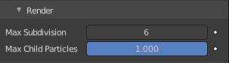
Render
This section affects the rendering with Eevee to file.

Max Subdivisions
Limit the number of maximum subdivisions.

Child Particles
Limit the number of child particles.

Animate Property
This properties can be animated. Activating this button sets a keyframe.

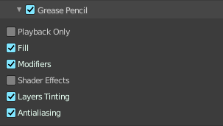
Grease Pencil
This section affects Grease Pencil drawings.

Playback Only
Simplify Grease Pencil only during animation playback.

Fill
Display Fill strokes in the Viewport.

Modifiers
Apply modifiers in the viewport.

Shader Effects
display shader effects.

Layers Tinting
Display layers tint.

Antialiasing
Use antialiasing to smooth stroke edges.

Simplify panel

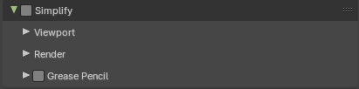
Sometimes you want to simplify the rendering without to loose the already tweaked settings and adjustments. For test renderings for example. Simplify allows you to set global limits on subdivision, shadow samples and more.

Enable
In the header is a checkbox to enable Simplify.

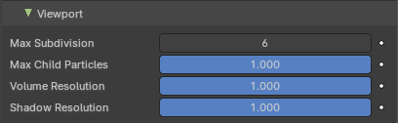
Viewport
This section affects the rendering with cycles in the Viewport.

Max Subdivisions
Limit the number of maximum subdivisions.

Max Child Particles
Limit the number of child particles

Volume Resolution
Simplify volumes by adjusting volume percentage of volume objects in viewport.

Shadow Resolution
Resolution percentage of shadows in viewport.

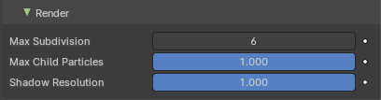
Render
This section affects the final rendering.

Max Subdivisions
Limit the number of maximum subdivisions.

Max Child Particles
Limit the number of child particles

Shadow Resolution
Resolution percentage of shadows in viewport.

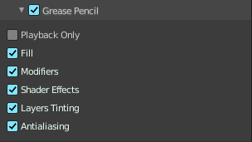
Grease Pencil

Playback Only
Simplify the grease pencil strokes only during playback.

Fill
Display Fill strokes in viewport.

Modifiers
Display Modifiers.

Shader Effects
Display Shader effects.

Layers Tinting
Display layer tint.

Antialiasing
Use antialiasing to smooth stroke edges.

